Ex. No.: 7
SNORT IDS
AIM:
To demonstrate Intrusion Detection System (IDS) using snort tool.
ALGORITHM:
1. Download and extract the latest version of daq and snort
2. Install development packages - libpcap and pcre.
3. Install daq and then followed by snort.
4. Verify the installation is correct.
5. Create the configuration file, rule file and log file directory
6. Create snort.conf and icmp.rules files
7. Execute snort from the command line
8. Ping to yahoo website from another terminal
9. Watch the alert messages in the log files

OUTPUT:
[root@localhost security lab]# cd /usr/src
[root@localhost security lab]# wget https://www.snort.org/downloads/snort/daq-2.0.7.tar.gz
[root@localhost security lab]# wget https://www.snort.org/downloads/snort/snort2.9.16.1.tar.gz
[root@localhost security lab]# tar xvzf daq-2.0.7.tar.gz
[root@localhost security lab]# tar xvzf snort-2.9.16.1.tar.gz
[root@localhost security lab]# yum install libpcap* pcre* libdnet* -y
[root@localhost security lab]# cd daq-2.0.7
[root@localhost security lab]# . /configure
[root@localhost security lab]# make
[root@localhost security lab]# make install
[root@localhost security lab]# cd snort-2.9.16.1
[root@localhost security lab]# . /configure
[root@localhost security lab]# make
[root@localhost security lab]# make install
[root@localhost security lab]# snort --version
,,_ -*> Snort! <*-
o" )~ Version 2.9.8.2 GRE (Build 335)
'''' By Martin Roesch & The SnortTeam: http://www.snort.org/contact#team
Copyright (C) 2014-2015 Cisco and/or its affiliates. All rights reserved.
Copyright (C) 1998-2013 Sourcefire, Inc., et al.
Using libpcap version 1.7.3
Using PCRE version: 8.38 2015-11-23
Using ZLIB version: 1.2.8
[root@localhost security lab]# mkdir /etc/snort
[root@localhost security lab]# mkdir /etc/snort/rules
[root@localhost security lab]# mkdir /var/log/snort
[root@localhost security lab]# vi /etc/snort/snort.conf
add this line- include /etc/snort/rules/icmp.rules
[root@localhost security lab]# vi /etc/snort/rules/icmp.rules
alert icmp any any -> any any (msg:"ICMP Packet"; sid:477; rev:3;)
[root@localhost security lab]# snort -i enp3s0 -c /etc/snort/snort.conf -l /var/log/snort/

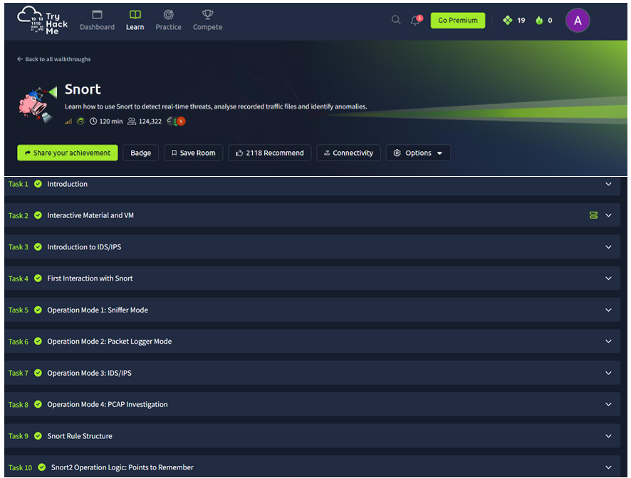

RESULT: Thus, the Intrusion Detection System (IDS) has been successfully demonstrated using snort.

